Data Analytics
RMDA2 Admin Tracking
Design Specifications

Template Revisions | Date | Change
V1.0 | 05/08/2009 | Initial Version



© 2009 CSC. Falls Church, Virginia. All rights reserved. No part of this publication may be reproduced by any means without written permission from CSC. Printed in U.S.A. All questions regarding this documentation should be routed through customer assistance, Blythewood, SC, 800-420-6007 or email pcssupport@csc.com.

Table of Contents

1. Introduction 3
2. Requirement Overview 3
2.1. Assumptions 3
2.2. Current Scenario 3
2.3. Proposed Scenario 4
3. Solution 4
3.1. Admin Tracking Dynamic Implementation 4
3.2. Import Logic 5
3.2.1. SP_AT 6
3.2.2. SP_AT_POPULATE 7
3.2.3. SP_AT_VALIDATE 9
3.2.3.1. Perform Validations 10
3.2.3.2. Check and mark records that need to be updated 10
3.2.3.3. Lookup for Foreign Key IDs 10
3.2.3.4. Add new codes to RMX database 10
3.2.3.5. Generate a verification diary entry and send notifications 12
3.2.4. SP_AT_IMPORT 12
4. Description of Screen Form or Page 12
5. Database Design 12
6. Processing Edits 13
7. Errors/Error Handling 14
8. Interdependencies and Interactions 15
9. Interface Information 15
10. Application / Technical Impact 15
11. Performance 15
12. Security 15
13. What to Test 15
14. Specification Signoff 17
15. References 18
16. Specification Change Log 19

Introduction

The RISKMASTER suite of solutions for Risk Management has evolved over the past months to new and more robust platform; however RISKMASTER still depends on a few legacy applications to allow customers interface from/to existing systems. One of these existing legacy applications is the Data Import System (DIS), this application has been built using Microsoft Visual Basic 6.0.

The main objective of this project is migrate the existing functionality already implemented on the legacy Data Import System (DIS) application to a new platform based on SAP Business Objects Data Services XI 3.2. The new functionality will be known to RISKMASTER clients as Data Analytics (DA DIS) modules.

This document focuses exclusively on the DA DIS Admin Tracking (AT) Import process, which is part of the Data Analytics DIS (DA DIS) project.

Requirement Overview

RISKMASTER X (RMX) clients currently using the Data Import System (DIS) need to be able to execute the DA DIS Admin Tracking (AT) process by using the RMX Task Manager Utility. DIS functionality will be integrated into Data Analytics however DA DIS AT functionality needs to be implemented as a Stored Procedure.

Assumptions

- The new DA DIS AT import process will be developed against RMX R6 database (Oracle or SQL Server databases).

- The new DA DIS AT import process will be developed as a Stored Procedure.

- Valid source (input) format file is: MS Access Database SampleDis32.mdb.

Current Scenario

Current RISKMASTER customers use the DIS application to import data from their existing systems into the RISKMASTER database. The DIS application was built with Microsoft Visual Basic 6.0, this platform is not longer supported by Microsoft. Also the DIS application architecture does not allow easy maintenance and require exhaustive development efforts to be upgraded.

DIS allows the execution of the import process that pulls data from the source MS Access database into the RM Database tables.

Proposed Scenario

Similar functionality will be developed using a modern and more robust architecture based on SAP Business Objects XI 3.2 Data Services. Users will use RMX Task Manager to schedule the DA DIS Admin Tracking job.

A new set of Stored Procedures will be created to perform the Import tasks.

Solution

A new set of stored procedures will be created for SQL Server and Oracle databases. These stored procedures will open the MS Access source database and will copy data into the RMX Database.

Admin Tracking Dynamic Implementation

DA DIS AT import logic is quite different compared with other DIS import areas. AT is in fact a subset of dynamic import areas that can be imported into the RISKMASTER database. When we say that is dynamic we refer to the fact that in order to import this information we need to look for a metadata repository to load table structure and proceed according to the metadata specification. The metadata repository is composed by 3 main tables: GLOSSARY, GLOSSARY_TEXT and SUP_DICTIONARY.

GLOSSARY and GLOSSARY_TEXT tables contain (among other data) the list of AT tables. The following SQL Sentence is used to retrieve the list of supported AT tables:

SELECT GT.TABLE_NAME,
G.SYSTEM_TABLE_NAME
FROM GLOSSARY G, GLOSSARY_TEXT GT
WHERE G.GLOSSARY_TYPE_CODE = 468
AND G.TABLE_ID = GT.TABLE_ID
ORDER BY GT.TABLE_NAME

In the previous sentence the field TABLE_NAME is used by the UI to display friendly table names. The field SYSTE_TABLE_NAME is the actual physical name of the table in database.

The SUP_DICTIONARY table contains the list of the specific fields contained on every AT table. The following SQL Sentence returns the list of fields contained in the BONDS_ABS table.

SELECT SYS_FIELD_NAME,
FIELD_TYPE,
FIELD_ID,
CODE_FILE_ID
FROM SUPP_DICTIONARY
WHERE SUPP_TABLE_NAME = 'BOND_ABS'

In theory new table specifications can be added to the metadata repository and they should be available for import through the DA DIS Admin Tracking module.

Import Logic

Execution Diagram

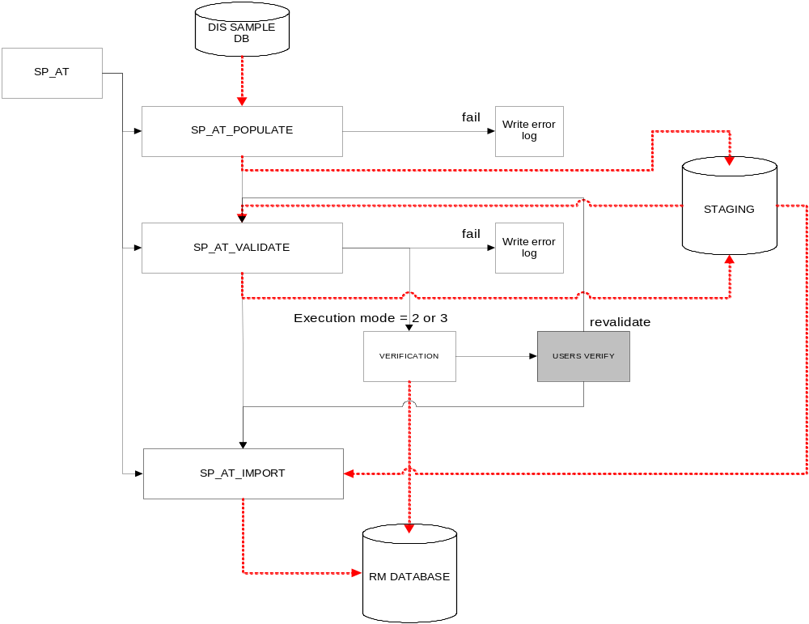

SP_AT

Overview:

This Stored Procedure serves as a unique entry point to the different internal processes. Basically this stored procedure makes the calls to the necessary stored procedures based on the @gAdminTrack_ExecutionMode parameter.

Parameters:

Parameter | Description
@gJobId (*) | This parameter contains the current JobId
@gAdminTrack_source_database | Contains the physical path and name to the MS Access source database
@gAdminTrack_area | Contains the physical name of the table to be imported
@gAdminTrack_add_update | Defines if the process should assume all records are new or not.
@gAdminTrack_match_field | Contains the name of the field used to validate if a record exists or nor.
@gAdminTrack_create_new_codes | Defines if the process should create new codes or not.
@gAdminTrack_ExecutionMode | This parameter is used to define the execution flow

(*) Need to verify if this value can be calculated.

Description:

This stored procedure controls the necessary calls to the internal stored procedures depending on the value of the @gAdminTrack_ExecutionMode parameter.

If @gAdminTrack_ExecutionMode = 1 then the execution flow will be as follows:
SP_AT_POPULATE
SP_AT_VALIDATE
SP_AT_IMPORT
Note: This flow mode is used when no verification process is required.

If @gAdminTrack_ExecutionMode = 2 then the execution flow will be as follows:
SP_AT_POPULATE
SP_AT_VALIDATE
Note: This flow mode is used when the user requests to perform a verification.

If @gAdminTrack_ExecutionMode = 3 then the execution flow will be as follows:
SP_AT_VALIDATE
SP_AT_IMPORT
Note: This execution flow is used after the user performs a verification but want data to be validated and then perform a verification again.

If @gAdminTrack_ExecutionMode = 4 then the execution flow will be as follows:
SP_AT_IMPORT
Note: This execution flow is used after the user performs a verification but don’t require a validation nor verification.

SP_AT_POPULATE

Overview
This stored procedure opens the Ms Access source database and store data into the Staging database. Not all the data is copied, only data related to the selected Admin Tracking import area.

Note:
This process assumes that the source MS Access database has been previously uploaded into the server via the User Interface (UI).

Parameters:

Parameter
@gJobId
@gAdminTrack_Source_Database
@gAdminTrack_Area
@gAdminTrack_match_field

Description

Based on the metadata repository for the imported area this stored procedure will open and read the MS Access source database and will populate the data into the staging database.

If a required field is missing an error log will be created on table ERROR_LOG, the following description will be used: “Required fields are missing in source table {Admin Tracking table name here}, missing fields: {missing field names here}”

The stored procedure will also define default values for the control fields located in every table of the staging database: JOBID (the current Job ID), INVALID_ROW (default value: 1), UPDATE_ROW (default value: 0), ROW_INT_ID (default value: a unique and sequential value).

If MS Access source database cannot be opened an error log will be created on table ERROR_LOG, the following description will be used: “The source MS Access database cannot be opened. Source Database: {@gAdminTrack_Source_Database} ”

Process metadata field-types

Metadata field-types are important because certain fields require special treatment when copying data from source database into the staging database. There are basically 3 groups of metadata field-types: Multi-values, foreign key description values and standard values.

Foreign Key Description Values

These fields behave as Foreign Keys to other tables, they can be recognized by the following field types:

FIELD_TYPE | Description
6 | Codes
8 | Entities
9 | States

In RMX database, these fields are of data type Integer and contain the actual Id values. On the MS Access source database these fields are of type Text and contain the actual description values, not the IDs.

In order to solve this issue the staging database will contain pairs of parallel fields, one will contain the descriptions and the other will contain the actual IDs.

For example:
BOND_LINE_CODE and BOND_LINE_CODE_DESC
COMP_TYPE_CODE and COMP_TYPE_CODE_DESC
ACT_TYPE_CODE and ACT_TYPE_CODE_DESC

The fields containing the postfix “_DESC” will contain the descriptors coming from source database. The fields without the “_DESC” postfix will be later populated with the actual Id values.

Note #1: Is not necessary that the metadata repository includes the descriptor fields (“xxxx_desc”) because the process will assume these already exist on staging database for fields having the field_type = 6, 8, and 9.

Note #2: Is important to upgrade the utility or user interface used to add new table specifications to the metadata repository in order to ensure the descriptor fields (“xxxx_desc”) are automatically added to the staging for fields having the field_type = 6, 8 and 9.

Multi-value

Multi-value fields contain multiple values concatenated in one single field.

Multi-value fields can be subcategorized as: Multi-code, multi-state and multi-entity fields.

The SUPP_DICTIONARY table keeps metadata that can be used to learn which fields belong to the multi-value category and subcategory.

The field SUPP_DICTIONARY.FIELD_TYPE should be used to differentiate multi-value fields. See the following list of field types values.

FIELD_TYPE | Description
14 | Multi-code
15 | Multi-state
16 | Multi-entity

When a multi-value field is identified the data contained in the field should be split because several values are stored in that single field, the values are concatenated and delimited using pipe characters, see the example below:

Multi-value-field = ‘value 1 | value 2 | value 3”

Source data stored on multi-value fields has to be inserted on the table SUPP_MULTI_VALUE.

FIELD | Value
FIELD_ID | Use the FIELD_ID (table SUPP_DICTIONARY) associated to the field being processed as multi-value.
RECORD_ID | Use the ID of the AT import area record being inserted.
CODE_ID | Store the multi-value item

Standard Values

These values do not require special treatment, they are copied from the source database into the staging as they are. The only consideration is to ensure data values are consistent with the expected data types.

The following table display a list of the expected data types for each field type. Note that we are displaying non-platform dependent data types because data types vary in SQL Server and Oracle.

FIELD_TYPE | Description
0 | String
1 | Integer
2 | Float
3 | Date
4 | Time
5 | Long string
7 | Integer
10 | Long string
11 | Long string
12 | Long string
12 | Long string

SP_AT_VALIDATE

Overview

This stored procedure will perform basic validations and data processing on the staging database depending on execution parameters.

Parameters

Parameter
@gJobId
@gAdminTrack_Area
@gAdminTrack_Add_Update
(@gAdminTrack_create_new_codes
@gAdminTrack_ExecutionMode

Description

This stored procedure will perform the following actions on the staging database:

Perform Validations

- Verify data values correspond to expected data types.

All records that pass validations will be marked by setting the field INVALID_ROW=0

All records having errors will generate an error log in the ERROR_LOG table of the RMX database. The description of the error should be: “Required fields are missing in source table {Admin Tracking table name here}, record number: {associated ROW_INT_ID value here}, missing fields: {missing field names here}”

Check and mark records that need to be updated

If @gAdminTrack_Add_Update = 0
The stored procedure must assume all records are new, all records will be marked changing the field UPDATED_ROW = 0

If @gAdminTrack_Add_Update = 1
The stored procedure must check if records should be added or updated. The criteria to determine if the record should be added or updated is given by the parameter @gAdminTrack_match_field which contains the name of the field that should be used to check if the record already exists on RMX database. For every record on staging database this process must determine if the record should be updated or added by setting the field UPDATED_ROW. A zero value indicates the record must be added, a non-zero value indicates the record must be updated.

Lookup for Foreign Key IDs

During this process the system should perform a database look up for all the descriptor fields and populate their corresponding ID fields.

Add new codes to RMX database

When parameter @gAdminTrack_create_new_codes = 0 the system will not add to the database non-existing codes. If a non-existing code is processed the system should mark the record as invalid by setting the INVALID_ROW = 1 and a new error log should be recorded. The description should be: “Record cannot be added because is referencing a non-existing Code. Record number: {ROW_INT_ID here}, field: {field name here}, code: {code descriptor here}.”

When the parameter @gAdminTrack_create_new_codes = 1 the system will add non-existing codes into the RISKMASTER database, the following two tables need to be updated: CODES and CODES_TEXT.

In this context codes are only associated to the following source fields:

- COUNTRY_CODE
- EMAIL_TYPE_CODE
- BUSINESS_TYPE_CODE
- COST_CENTER_CODE
- SIC_CODE

A) How to update the Table CODE:

CODE_ID is a calculated field; the system must generate a new unique and sequential integer number.

SHORT_CODE is the new code description that was not found and needs to be added to the CODE table.

TABLE_ID is a value obtained based on which system table the code should be linked to. See the valid values:

If the source field is: | Associated System Table | table_id
COUNTRY_CODE | COUNTRY | 1024
EMAIL_TYPE_CODE | EMAIL_TYPE | 1110
BUSINESS_TYPE_CODE | BUSINESS_TYPE | 1166
COST_CENTER_CODE | COST_CENTER | 1104
SIC_CODE | SIC_CODE | 1165

Note: TABLE_ID values can be obtained from the GLOSSARY table.

The following fields are always set equal to zero:
- RELATED_CODE_ID
- LINE_OF_BUS_CODE
- DELETED_FLAG
- IND_STANDARD_CODE

B) How to update the table CODE_TEXT

CODE_ID is the same value assigned to parent record on table CODE.

SHORT_CODE is the new code that was not found and needs to be added to the CODE table.

CODE_DESC is always equal to SHORT_CODE

LANGUAGE_CODE is always the fixed value: 1033

Generate a verification diary entry and send notifications

If @gAdminTrack_ExecutionMode = 2 or If @gAdminTrack_ExecutionMode = 3 then the process should generate a verification diary entry with validation summary and verification link.

SP_AT_IMPORT

Overview
This process will copy data from staging to RMX database.

Parameters

Parameter
@gJobId
@gAdminTrack_Area

Description

This process copies records from staging to the RMX Database.

The process only copies data for records marked with the control field INVALID_ROW=0

The process Adds or updates data depending on the control field UPDATE_ROW.

If UPDATE_ROW = 1 then perform an update operation.

If UPDATE_ROW = 0 then perform an insert operation.

Description of Screen Form or Page

No new UI (screen forms or pages), or changes to existing interfaces will be developed as part of this requirement.

Database Design

A new database DA_RMX_STAGING will be created, the staging database will be RISKMASTER X alike but base tables will include 4 additional fields: JOB_ID, ROW_INT_ID, INVALID_ROW and UPDATED_ROW.

A new table to keep error logs will be created:

Table ERROR_LOG (RISKMASTER database):

Column Name | Data Type
ERR_LOG_ROW_ID | int
MODULE_NAME | varchar(50)
WORK_FLOW_NAME | varchar(50)
DATA_FLOW_NAME | varchar(50)
ERROR_TIME | varchar(50)
ERROR_DESC | varchar(500)
JOBID | int

Processing Edits

Parameter  (description) | Accepted values | Description
@gJobId | Integer value | This parameter contains the current JobID
@gAdminTrack_source_database | String value | Contains the physical path and name to the MS Access source database
@gAdminTrack_area | String value | Contains the physical name of the table to be imported.  The list of valid import areas is dynamically obtained from RM database:  SELECT g.system_table_name  FROM GLOSSARY G,  GLOSSARY_TEXT GT  WHERE g.glossary_type_code=468  AND g.table_id=gt.table_id  ORDER BY gt.table_name
@gAdminTrack_Add_Update | Integer value:  - Always add (0)  - Add or update (1) | The Always add option enforces the system to add all the records being imported as if they were new.  The Add or update option tells the system to perform a record checking to avoid duplicated values. The field used to enforce uniqueness must be provided by the user via the Match field parameter.
@gAdminTrack_match_field. | A string containing the name of the field used to validate if record already exists.  The list of possible matching fields depends on the selected import area. | The list of matching fields is only enabled when Add or update is selected.  Use the following SQL sentence to obtain the list of possible values:  SELECT sys_field_name,  field_id,  FROM SUPP_DICTIONARY  WHERE SUPP_TABLE_NAME = '[system_table_name here]'
@gAdminTrack_Create_New_Codes | Integer value:  - Don’t create codes (0)  - Create new codes (1) | When Allow creation of new codes is checked the import process automatically updates the tables CODES and CODES_TEXT to reflect new codes. See later in this document the rules to add new codes.
@gAdminTrack_ExecutionMode | Integer value, valid values are 1 to 4. | See 3.2.2, section description for a reference of the actions to perform for options 1 to 4.

Errors/Error Handling

DA DIS will use the ERROR_LOG table; all the stored procedures included in DA DIS Admin Tracking will have to populate this table in order to include all error messages generated during the import process.

Additionally each base table on DA_RMX_STAGING database will have a few additional columns, 2 of them will be used to handle errors: ROW_INT_ID and INVALID_ROW.

A new record will be created on the ERROR_LOG table for each invalid record found. Information about the column(s) where a validation error occurred is appended to the ERROR_COLUMNS column and should be delimited by semicolons. An informational message(s) about the nature of the validation errors should be appended to the ERROR_DESC column and delimited by an escaped newline character (\n). For each invalid record, the value of the record’s INVALID_ROW flag is increased by 1.

Refer to RMDA2 TDS DIS Overall Process to get the complete details about errors handling.

Screen name: | Admin Tracking Import process
Field name: | n/a
Error: | Required fields are missing.
Display type:  (Message Box or Beep) | Error Log
Message text: | “Required fields are missing in source table {AT table name here}, record number: {associated ROW_INT_ID value here}, missing fields: {missing field names here}”
System Action: | Save a record log into the ERROR_LOG table
User Action: | Review error log and take proper actions.
Potential Causes: | Data source contains invalid data.
Resolution: | User should open the source file and manually fix the issues described in the error log.

Interdependencies and Interactions

The following systems/solutions are directly linked to this requirement:
- RMX Task Manager included as a Utility in RMX R6.
- RM TaskManager Service.

Interface Information

DA DIS Admin Tracking will interact with a Microsoft Access DB as data source (input) and the RMX DB (SQL Server or Oracle) as data target (output).

Application / Technical Impact

The new modules will completely substitute the existing DIS application.

Performance

Since we are converting a desktop application to a web based enterprise application, there are no possible ways to measure the performance during design time. However, based on previous modules that were converted to this platform, we were able to improve the performance by using this tool.

Security

Import Job will run under the context of a predefined system user. Jobs can be requested by authorized users using the Task Manager however the job will run under the system user context.

What to Test

- Prepare a SampleDis32.mdb file (source), it should include valid and invalid records clearly identified based in the current data stored in RISKMASTER X DB. Put the MDB file in the corresponding execution folder.
- Start SQL Server Management Studio or it’s equivalent in Oracle.
- Connect to the RMX database.
- Execute SP_AT stored procedure, manipulate parameters to simulate different criteria selection and direct access to different execution stages (Example: set @gAdminTrack_ExecutionMode=1 to execute the Admin Tracking import process without verification, set $gAdminTracking_Create_New_Codes = 1 to validate new codes creation).
- Check that all the Admin Tracking source records initially identified as valid, according to the RISKMASTER X DB and the selected criteria, were uploaded correctly to the corresponding AT table in RISKMASTER X DB.
- Any source record initially identified as invalid in the source AT table, should be listed in the corresponding error log file, all the details about why a record was discarded in the import process should be listed in the error description.
- Execute SP_AT, set @gAdminTrack_ExecutionMode=2, check if the Diary Process is being triggered correctly (refer to RMDA2 TDS DIS Overall Process to get more details about what to test for “Diary Process” tests).
- Verify the complete Import Process is working correctly for both SQL Server and Oracle DB environments.
- Refer to RMDA2 TDS DIS Overall Process and RMDA2 TDS DIS Criteria Screens to get more details about the Testing Plan for the complete DA DIS solution.

Specification Signoff

The signatures below represent approval and signoff of the requirements and approaches as listed above.

________________________________ _______________
Reviewer(s) Date

________________________________ _______________
Testing Lead Date

________________________________ _______________
Program Manager Date

________________________________ _______________
Development Manager Date

Comments: ___________________________________________________________________

References

- RMDA2 TDS DIS Overall Process
- RMDA2 TDS DIS Criteria Screens

Specification Change Log

Date | Change # | Requirement # Revised | Nature of Revision | Initials

